**Hotel Management System**

1. Creating the tables.

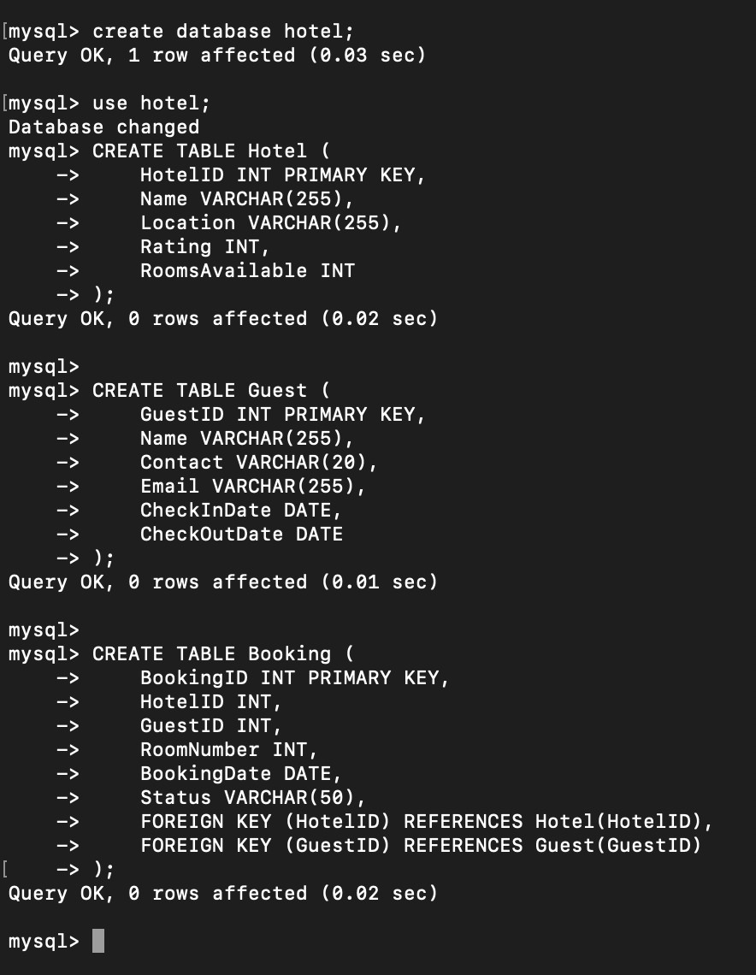

1. Inserting sample data.

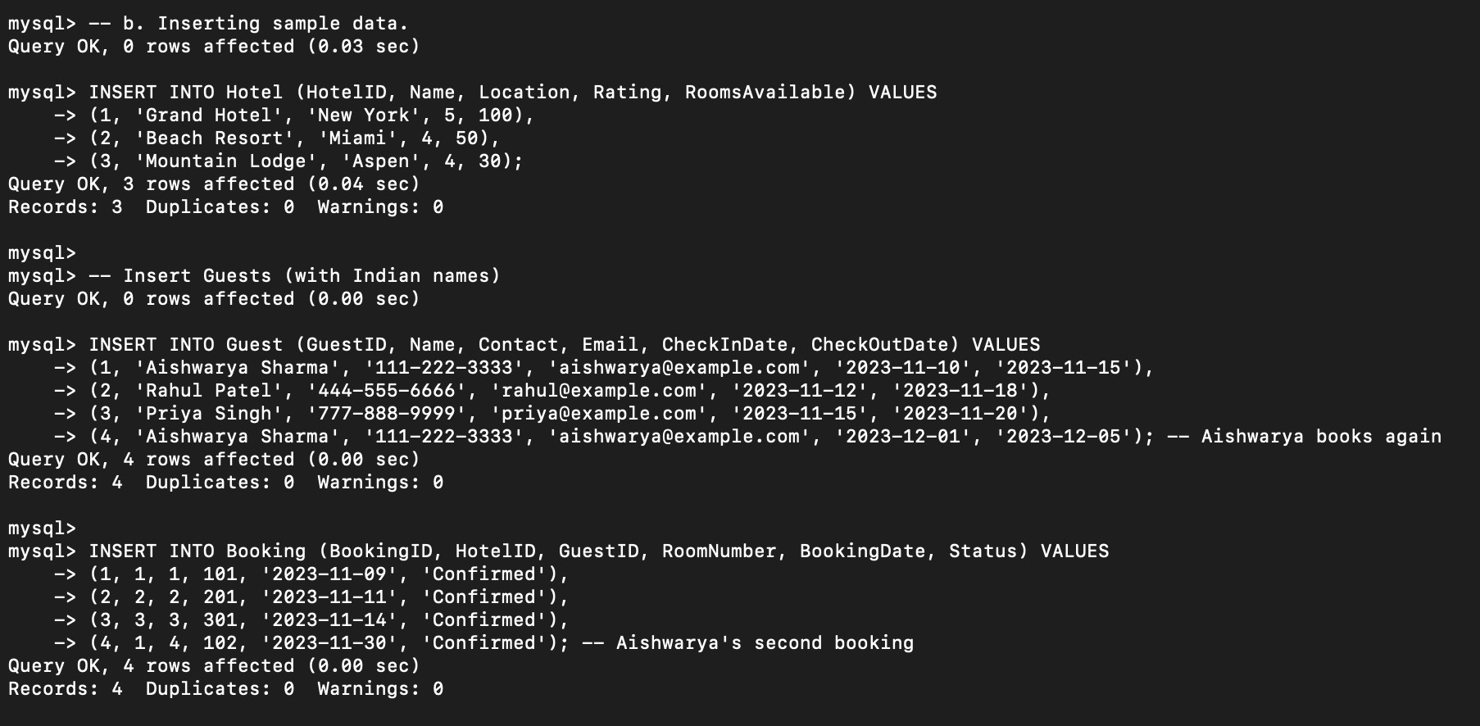

1. Retrieve hotels with the highest rating.

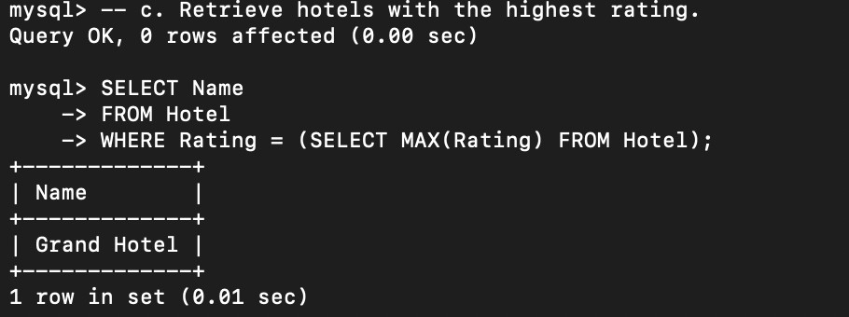

1. Find guests who have booked more than once.

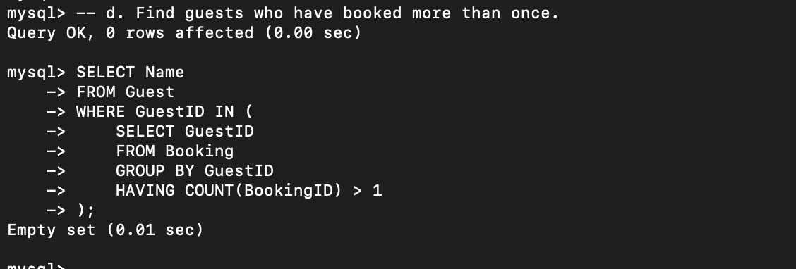

1. Display available rooms in a specific hotel.

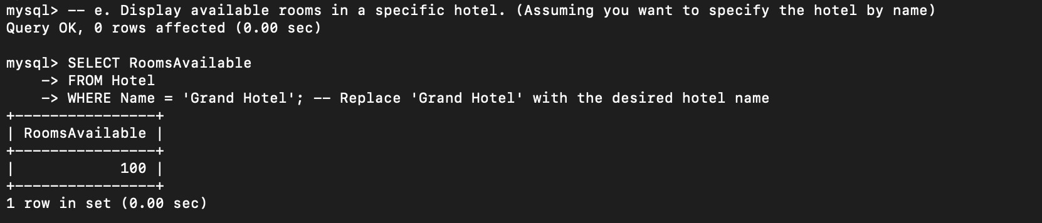

1. Retrieve total bookings per hotel.

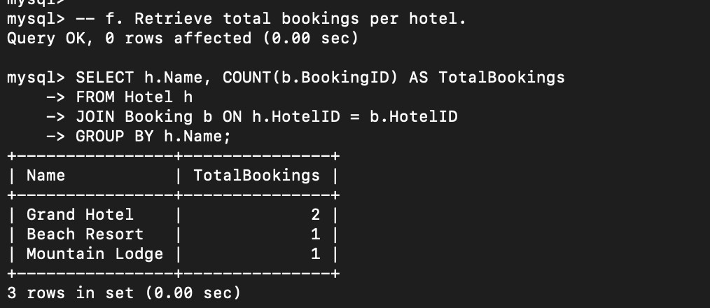

1. Find bookings made within the last month.

